The Respiratory System
The Gas Exchange System

- Consists of: ____________, diaphragm, ________________, larynx and pharynx
- Primary function: bringing _____________ into the body and help remove ____________ gases from the body
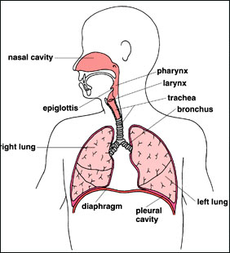

- Inhalation (_____________): contraction of diaphragm causes lungs to ________________ in size which creates a vacuum so air is pushed __________ the lungs.
- Exhalation (______________): diaphragm relaxes which causes the lungs to ________________ in size and increase in pressure which pushes the air __________ of the lungs
- When ____________, respiration ____________________ to bring more oxygen into the body. When _______________, respiration will ___________________ since less oxygen in required by the body.

Pathway of Air
________________(mouth) → pharynx → larynx → ______________ → bronchi → bronchioles → ______________

http://www.youtube.com/watch?v=HiT621PrrO0&feature=related

______________ Cavity – air is warmed and moistened
______________ – connects the ____________ and oral cavities with the esophagus and _______________
_________________ – located at the top of the trachea, this is where the vocal chords (___________________) is located
______________________ – thin ____________ on top of the trachea that keeps food and water from entering the trachea.
_________________ – tube with rings of cartilage (can be felt in front of neck) that transport air between the ____________ and ______________.
_______________ – large tubes that connect the _______________ to the bronchioles
_____________________ – smaller tubes that branch off and connect the bronchi with the ______________
______________ – tiny __________ in the lungs that are surrounded by capillaries where air ________________ occurs between the lungs and blood. ______________ diffuses into the blood and waste gases such as _____________________________ diffuse into the alveoli to be exhaled.

