Notes – The Skeletal System

http://www.youtube.com/watch?v=vya4wpS2fgk
Composed of: ____________, cartilage, ligaments and ______________

Function:
- Provide _______________ and shape to the body
- _____________________ of internal organs
- Locomotion (_________________)
- Produce _____________ cells
- ______________ minerals and nutrients

Components
- ________________ – flexible material that attaches ____________ to ______________
- ____________________ – flexible material that attaches ______________ together
- _____________________ – flexible material that acts as a shock ________________ in joints and also gives _____________ to certain parts of the body
- _______________ – hard material for _________________, protection and blood production

http://www.youtube.com/watch?v=UGTenIDJBwU&feature=related

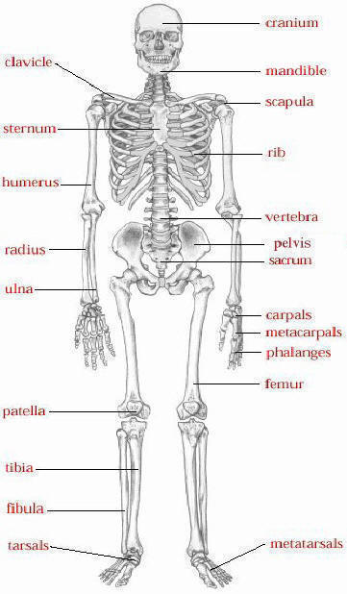

Human body has __________ bones.

http://sv.berkeley.edu/showcase/pages/bones.html
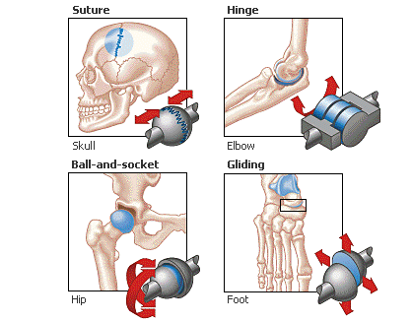
http://www.youtube.com/watch?v=dMglTDY-JOQ&feature=related

