**The Muscular System**

[**http://www.dnatube.com/video/2115/Anatomy-Muscle-Types**](http://www.dnatube.com/video/2115/Anatomy-Muscle-Types)

**Types of Muscle Tissue**

**___________________ muscle** – located only in the _________________ – constantly contracting and relaxing

**______________ muscle** – located in ______________ (except the heart) – contracts to help move materials through your organs

**__________________ (striated) muscle** – attach to _______________ by tendons and responsible for ________________ the bones to provide motion. They are the most common type of muscle in the body

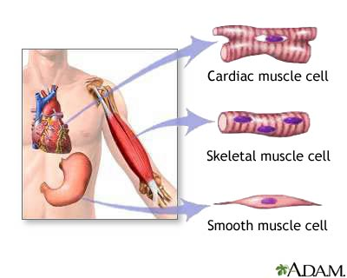

**Function of Skeletal Muscle**

_____________________

Stabilize the body/________________

_____________ production

_____________________

<http://health.howstuffworks.com/human-body/systems/musculoskeletal/adam-200006.htm>

**Muscle Facts**

There are over _________ muscles in the body which is approximately ________% of the total body weight.

Most muscles work in antagonistic ___________ since muscles can only __________ – not push. Therefore, one muscle __________________ while the other ________________ and then vice versa.

Every person has a unique ______________ print.

It takes ________ muscles to smile and ________ to frown.

<http://www.youtube.com/watch?v=RsWNyqnHQ2I>

