Notes – The Circulatory System
The Transportation System

http://www.gamequarium.org/cgi-bin/search/linfo.cgi?id=12096
Composed of ____________, blood vessels and ____________
Function: ___________________ materials throughout the body to cells and take ____________ products away from cells

The Heart
  - __________ Chambers
    - left and right __________ receive blood to the heart
    - left and right ____________________ pump blood away from the heart
  - ____________ open to allow blood to pass through and close to prevent _________________
  - ___________________ node – area above the right atrium that generates a normal sinus ______________ (causes the heart to beat)
http://www.argosymedical.com/Circulatory/samples/animations/Heart/index.html

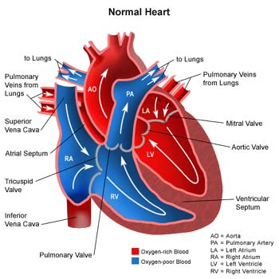

The Blood Vessels
- _____________ – carries blood __________ from the heart
- __________ – carries blood _____________ the heart
- ______________________ – connect arteries and veins; they are so ____________ that nutrients and oxygen diffuse right through them

The Blood
http://www.argosymedical.com/Circulatory/samples/animations/The%20Blood/index.html
- Composed of
  - _____________ – yellowish _____________ part of blood that carries nutrients, clotting factors, sugar, hormones, etc.
  - _________ blood cells – erythrocytes - made in the bone marrow - carry ______________ and carbon dioxide – hemoglobin gives them the red color
  - ____________ blood - leukocytes – made in bone marrow, lymph tissue, thymus, spleen – ______________ the body against invaders
  - __________________ - thrombocytes – aid in _____________ of blood – formed in bone marrow

