Carbon Cycle and Human Impact on the Environment

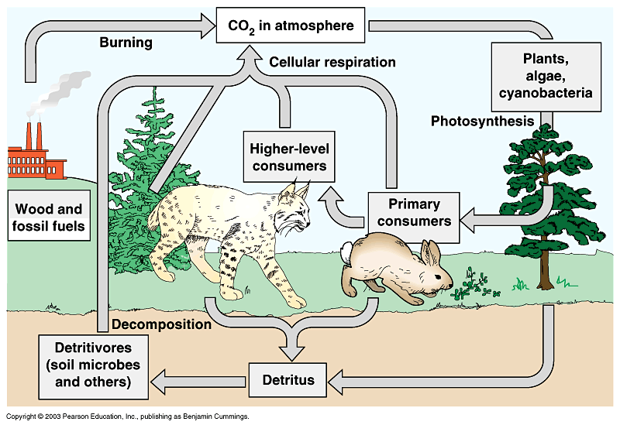

Causes of Deforestation
- Used for Urban and _________________________ Purposes: The cutting down of trees for lumber that is used for building materials, furniture, and paper products. Forests are also cleared in order to accommodate expanding urban areas such as buildings and highways.
- To Grow _______________: Forests are also cut down in order to clear land for growing crops.
- To Create __________________ Land: Forests are cut down in order create land for grazing cattle.
- Used for ____________: Trees are cut down in developing countries to be used as firewood or turned into charcoal, which are used for cooking and heating purposes.

Effects of Deforestation
- ___________________ of Soil: When forest areas are cleared, it results in exposing the soil to the sun, making it very dry and eventually, infertile, due to volatile nutrients such as nitrogen being lost. In addition, when there is rainfall, it washes away the rest of the nutrients, which flow with the rainwater into waterways.
- Disruption of the _________________ Cycle: Trees contribute in a large way in maintaining the water cycle. They draw up water via their roots, which is then released into the atmosphere. A large part of the water that circulates in the ecosystem of rainforests, for instance, remains inside the plants. When these trees are cut down it results in the climate getting drier in that area.
- Loss of _________________________: Even though tropical rainforests make up just 6 percent of the surface area of the Earth, about 80-90 percent of the entire species of the world exist here. Due to massive deforestation, about 50 to 100 species of animals are being lost each day. The outcome of which is the extinction of animals and plants on a massive scale.
- __________________ and Drought: One of the vital functions of forests is to absorb and store great amounts of water quickly when there are heavy rains. When forests are cut down, this regulation of the flow of water is disrupted, which leads to alternating periods of flood and then drought in the affected area.
- ___________________ Change: It is well known that global warming is being caused largely due to emissions of greenhouse gases like carbon dioxide into the atmosphere. Trees act as a major storage depot for carbon, since they absorb carbon dioxide from the atmosphere, which is then used to produce carbohydrates, fats, and proteins that make up trees. When deforestation occurs, many of the trees are burnt or they are allowed to rot, which results in releasing the carbon that is stored in them as carbon dioxide. This, in turn, leads to greater concentrations of carbon dioxide in the atmosphere.

Causes of _______________________________
- Overgrazing and poor grazing management
- Incorrect irrigation management
- Forest removal
- Soil fertility degradation
- Climate change

Effects of _______________________________
- Overgrazing and poor grazing management
- Incorrect irrigation management
- Forest removal
- Soil fertility degradation
- Climate change

Causes of ___________________________
- Population growth
- Modernization
- Industrialization
- Economics – reduce time and expense

Effects of __________________________
- Increase in temperatures
- Change in water cycle and absorption of water into the soil
- Intensification of air and water pollutants
- Flooding
- Habitat destruction

Human Impact on ________________ Availability and Flow
- Population growth – household, agricultural, industrial, recreational
- Climate change
- Water pollution
- Urbanization

Effects of Water __________________
- Kills organisms that live in or near the water
- Disrupts natural food chains
- Can cause sickness or death in humans
- Reduces available safe drinking water

Effects of ________________ Fuels
- Burning of fossil fuels produces:
  - sulfuric, carbonic and nitric acids which contribute to acid rain
  - Additional air pollutants include heavy metals, carbon monoxide, carcinogens
  - Greenhouse gases
- Mining, drilling and transportation have negative and hazardous consequences as well, such as strip mining and oil spills

